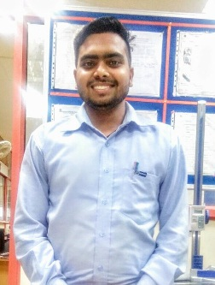

RIT helped me to complete my dreams. Currently I am working in Shriram Piston & Rings Ltd. (USHA Group) which is a reputed MNC company. RIT gave me this great platform in campus placement. I got lots of knowledge and learning from RIT & A good Job. RIT is the Best Institute in North INDIA. Thank you RIT

Rupesh Kumar

Mechanical Engg. (Production)



Currently, I am working in Rane NSK Steering System Pvt. Ltd., Pantnagar.

RIT has given me a great platform to showcase my performance. The technical knowledge from reputed faculties has helped me in getting a good job. I thank my college, my teachers and all supporting staff for lightening up my career.

Thank you RIT.

Deepanshu Sharma

Mechanical Engg. (ProductioN)

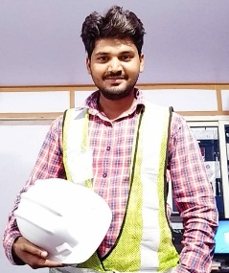

RIT is an institute where all students get opportunities in various fields & Institute creates analytical skills in students so students become confident about their talent. RIT provided me a great platform for getting a good job. Currently I am working in Unique mep projects pvt Ltd.

Thanks RIT

Rohitashwa Singh

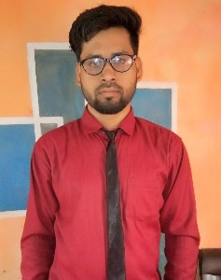

RIT is the best for study & placements. The most reputed companies come to offer jobs in RIT. TATA, BAJAJ, HONDA, SPRL, TOYODA, Rane NSK, Motherson sumi systems, Unique MEP and many more companies are there which come to here in RIT for placement. Currently I am working in BAJAJ. I am proud to be a RITian.

Thanks RIT for giving a wonderful direction to my life. Thanks

Mohar Singh

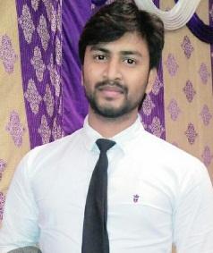

As a student I enjoyed my life in RIT, Institute provides good environment for study and extracurricular activities. RIT always motivates to learn and to do something great in life.

A great place where knowledgeable faculty, good environment, great placement opportunities are available. Currently I am working in JTEKT Sona automotive India ltd which is a reputed Company.

Sanchit Jaiswal

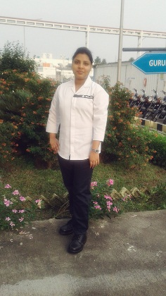

A wonderful place to explore all your knowledge and talent. Every dream starts with this stage and it's up to the student to utilize it in a wise manner. semester wise examination with a standard assessment, it's not hectic but just all over cool. College adds to a regular mind refreshing events and an amazing placement opportunities.....

Thanks

Ashi Agrawal